Ethernet Transmitter Algorithm

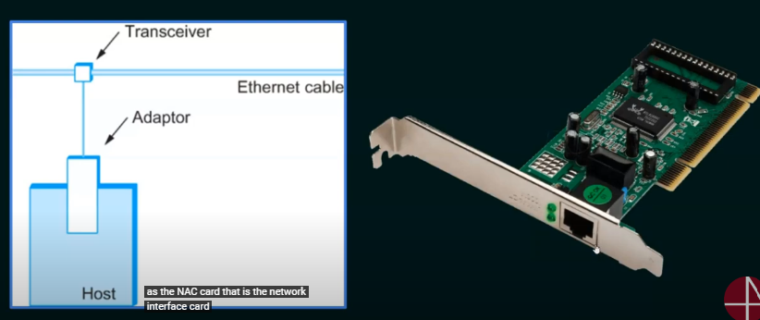

**Access Protocol for Ethernet**

The algorithm is commonly called Ethernet’s Media Access Control(MAC) which is implemented in Hardware on the network adaptor.

**Access Method of Ethernet**: CSMA/CD

**Encoding method**: Manchester Encoding Technique for converting data bits into signals.

Ethernet Transmitter Algorithm

1. When the adapter has a frame to send and the line is idle, it transmits the frame immediately.
2. The upper bound of 1500 bytes in the message means that the adaptor can occupy the line for a fixed length of time
3. When the adapter has a frame to send and the line is busy, it waits for the line to go idle and then transmits immediately.
4. The ethernet is said to be CSMA 1-persistent protocol because an adaptor with a frame to send transmits with probability 1 whenever busy line goes idle.
5. SSince there is no centralize control it is possible for two (or more) adaptors to begin transmitting at the same time, either because both found the line to be idle or, both had been waiting for a busy line to become idle.
6. When this happens, the two or more frames are saif to be collide on the network
7. Since Ethernet supports collision detection, each sender is able to determine that a collision is in progress
8. At the moment an adaptor detects that its frame is colliding with another, it first makes sure to transmit a 32-bit jamming sequence and then stops transmission
9. Thus, a transmitter will minimally send 96 bits in the case of a collision 64-bit preamble + 32-bit jamming sequence

Runt Frames

1. A runt frame is an Ethernet frame that is less than IEEE 802.3’s minimum length of 64 bytes
2. Runt frames are most commonly caused by collisions.
3. Other possible causes are malfunctioning network card, buffer underrun, duplex mismatch or software issues.

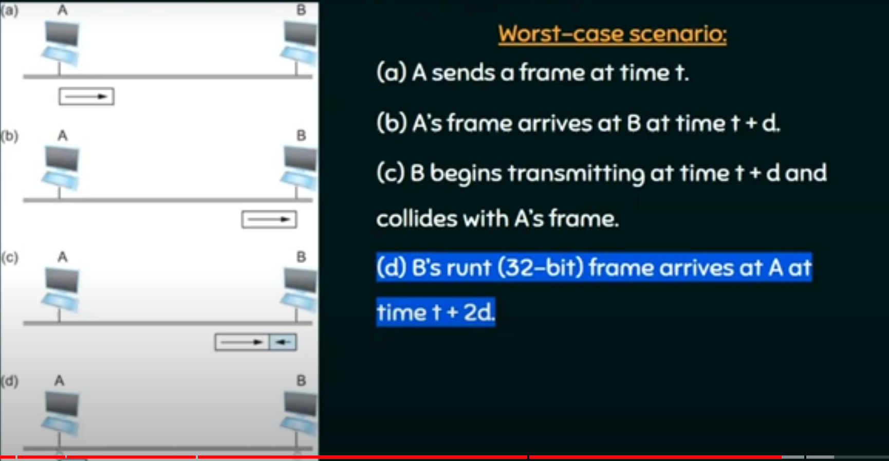

Exponential Backoff

1. Once an adaptor has detected a collision, and stopped its transmission it waits a certain amount of time and tries again
2. Each time the adaptor tries to transmit but fails, it doubles the amount of time it waits before trying again
3. This strategy of doubling the delay interval between each retransmission attempt is known as Exponential Backoff.